Project Design Phase
Problem – Solution Fit Template

Date | 20 February 2026
Team ID | LTVIP2026TMIDS73549
Project Name | Streamlining Ticket Assignment for Efficient Support Operations
Maximum Marks | 2 Marks

Problem – Solution Fit Template:
- Problem–Solution Fit refers to identifying real operational issues faced by users and ensuring that the proposed solution effectively resolves those challenges.
- In the ServiceNow Operations Ticket Management System, users experience delays, incorrect ticket routing, and dependency on manual support processes while reporting platform or certification-related issues.
- The developed solution introduces an automated ticket management workflow using ServiceNow Flow Designer, role-based access control, and intelligent group assignment. This ensures that operational issues are automatically routed to the appropriate support teams, reducing response time and improving service efficiency.
- The system aligns customer needs with automation-driven workflows, enabling faster issue resolution and improved operational productivity
Purpose:
- Solve operational support problems using automated workflow management aligned with user requirements.
- Improve solution adoption by integrating ticket handling within an existing ServiceNow platform environment.
- Enhance communication and response efficiency through automated triggers and smart ticket routing mechanisms.
- Build user trust by minimizing delays, reducing manual workload, and ensuring accurate issue assignment.
- Understand current manual support limitations and transform them into an efficient automated support ecosystem.

Template:
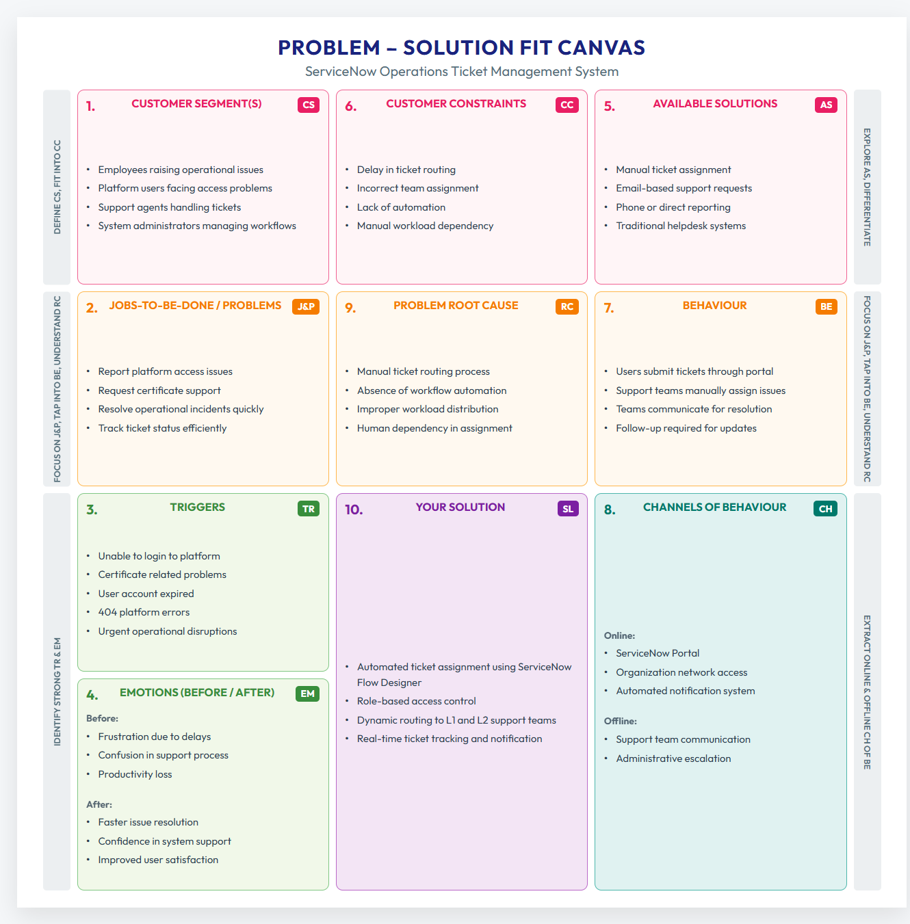
References:
- https://www.ideahackers.network/problem-solution-fit-canvas/
- https://medium.com/@epicantus/problem-solution-fit-canvas-aa3dd59cb4fe

